**Pet Adoption Management System**

INFO 330 Group 18:

Yixiang ‘Eric’ Fang

Yana Xu

Michaelangelo Labrador

***Preliminaries:***

1. **Description:**

The type of organization we are creating a database for is a pet shelter. Shelters house many animals that no longer have a home. They can range from being found stray, abandoned, or previously put up for adoption by past owners. The organization is having trouble keeping organized data on pets e.g., animal type, adoption process, and scheduled meeting times for potential adopters to meet a pet they may find suitable for their home. In order to pre-process approvals for adoption, the shelter wants to be able to give information on the pet that is accessible online. Additionally, they want to launch a volunteer program in order to help with pet care and facilitate pet meetings. Donations, such as pet food and toys, are being accepted daily and there is no way to keep track of such items in the facility to make sure they are not overstocking on other essential items. We aim to create a database that solves such issues in keeping pets healthy, allowing pet essentials to be up to date, and allowing volunteer information to be kept on record for future reference while keeping track of records for adoption.

1. **Information Needs:**

The Pet Adoption Management System is a platform designed to facilitate the adoption process while ensuring the well-being of animals in the program. The system operates by collecting detailed pet profiles containing information such as the pet's name, age, gender, color, health status, and behavioral traits. These profiles help potential adopters find suitable pets that match their preferences and lifestyles. Shelters include important information such as their name, location, contact information, operating hours, and capacity. This information helps in efficient coordination and resource management, making the adoption process smooth and straightforward. For the volunteers, the system collects information on volunteer names, contact details, availability schedules, and skill sets. This information helps ensure that pet care is well-coordinated and that the animals receive proper attention and care. The Breed entity information covers information like breed characteristics, average lifespan, common health issues, and origin. This information helps both potential adopters and shelter staff make informed decisions while selecting the right pet. By addressing these specific information needs, the Pet Adoption Management System aims to foster responsible pet adoption and care.

1. **Entities Identified List:**

* Pet: Name, Animal, breed, age, gender, health, behavior, and microchip status.
* Adoption Process: Application form, interview, home visit, adoption status, and date.
* Shelter: Shelter name, location, current number of pets, and capacity.
* Volunteers: Name, contact information, role, and availability.
* Adopters: Name, age, contact information, address, living condition, and pet ownership experience.
* Donations: Donor information, donation type, amount of donation, date, and frequency of donation.
* Pet Care: Assigned volunteer, volunteer availability, health care, exercise, nutrition, grooming, and social interaction with humans.
* Meeting: Date and time, location, details of the meeting, and feedback from potential adopters.

1. **Business Rules:**

* Pet Adoption:

1. Only potential adopters with an approved adoption application can adopt a pet.
2. A pet can only be adopted by one adopter at a time.

* Pet Care:

1. Many volunteers can be assigned to take care of many pets.
2. The scheduling of feeding and playtime sessions is based on the availability and preferences of both volunteers and pets.

* Meeting Times:

1. Meetings are organized to facilitate interactions between potential adopters and pets.
2. Meeting times are scheduled for adopters to meet and play with pets they are interested in adopting.
3. The system tracks the pets that adopters interact with during the meeting for further adoption process considerations.

* Adoption Process:

1. An adoption process involves a few steps: application, interview, and home visit.
2. Each adoption process is associated with one pet adoption.

* Donations:

1. Donations can be made to multiple shelters or for a specific purpose.

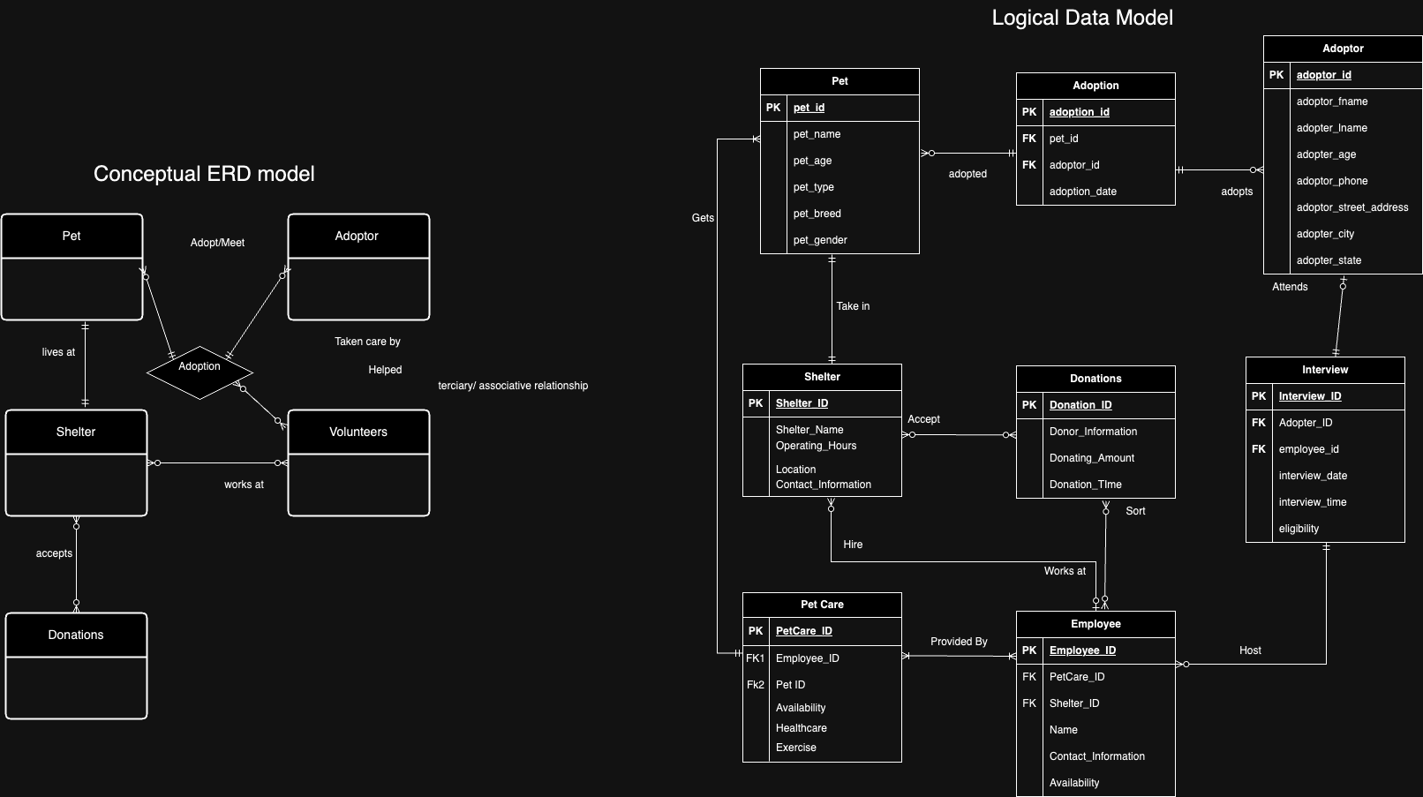

Relational Schema

-- Adoption (adoption_id, adoptor_id, pet_id, adoption_date)

-- Adoptors (adoptor_id, adoptor_fname, adoptor_lname, adoptor_gender, adoptor_age, adoptor_salary, adoptor_marital, adoptor_kids, adoptor_state, adoptor_city)

-- Donation (donation_id, donor_information, donating_amount, donation_time)

-- Employee (employee_id, petcare_id, shelter_id, name, contact_info, availability)

-- Interview (interview_id, adoptor_id, employee_id, interview_date, interview_time, eligibility)

-- PetCare (petcare_id, employee_id, pet_id, availability, healthcare, exercise)

-- Pets (pet_id, pet_name, pet_age, pet_type, pet_breed, pet_gender, pet_size, shelter_id)

-- Shelter (shelter_id, shelter_name, operating_hours, location, contact_information)